Assignment 3: Question Requirement

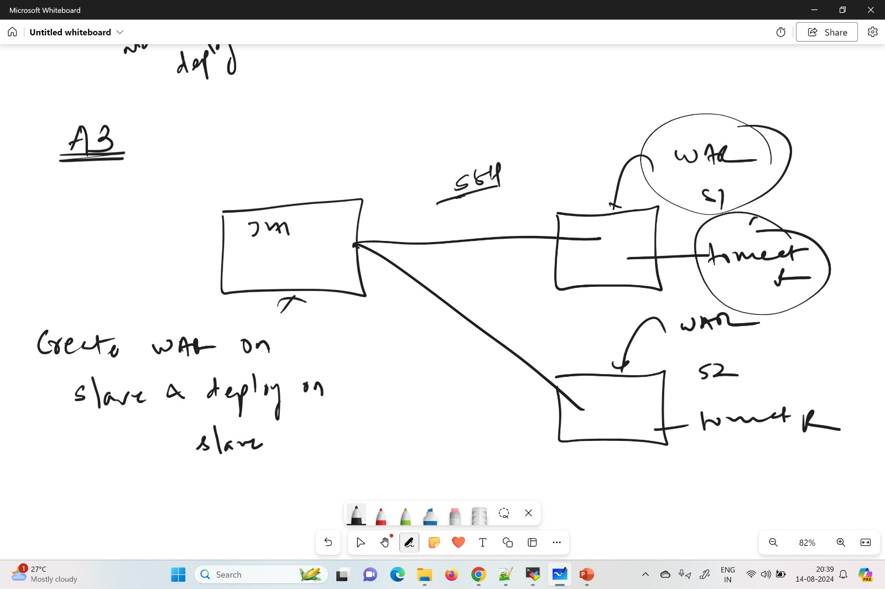

Launch 3 Ec2 Instances (1- Jenkins master and 2- Jenkins Slave)

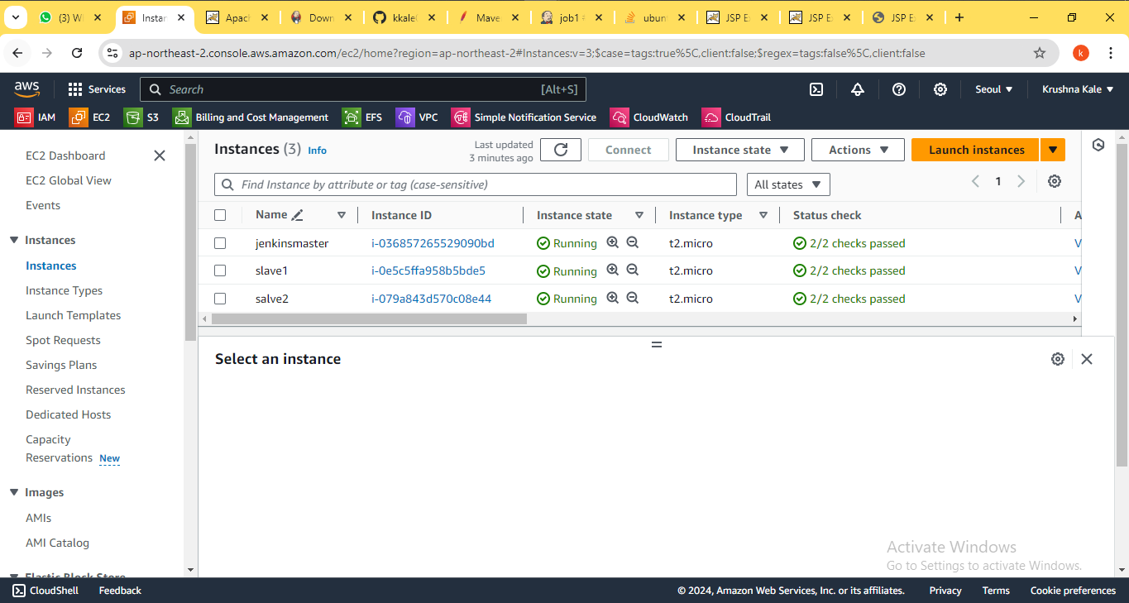

Created two node and make connection through SSH

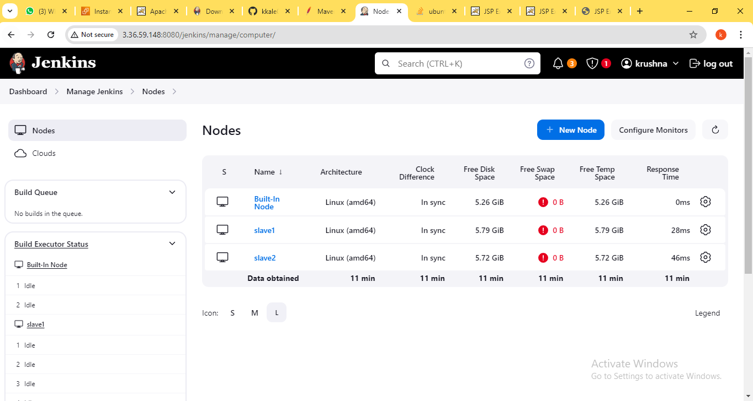

Created Two jobs which are run on slave respectively

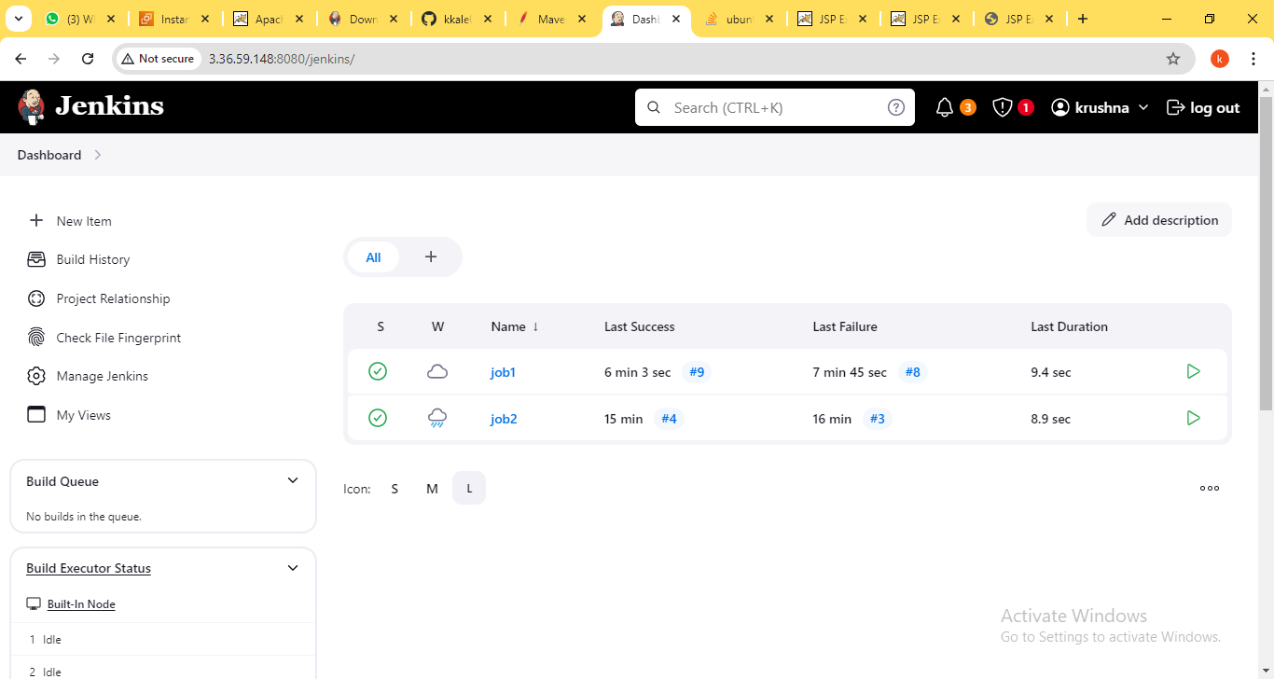

Job1 run successfully on slave1

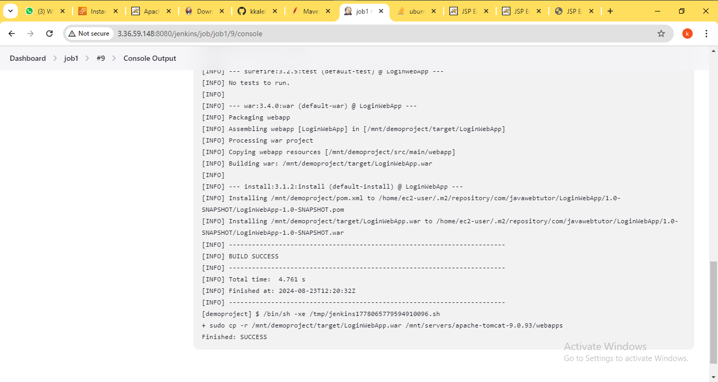

Build and war deploy on slave1

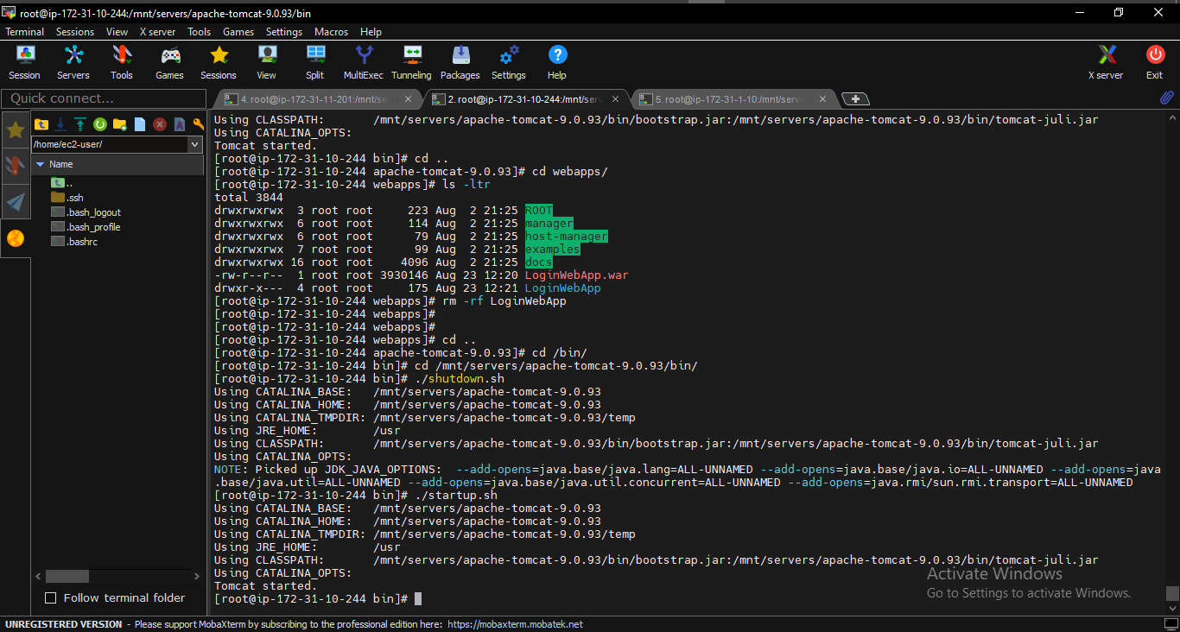

Deploy and confirm on web

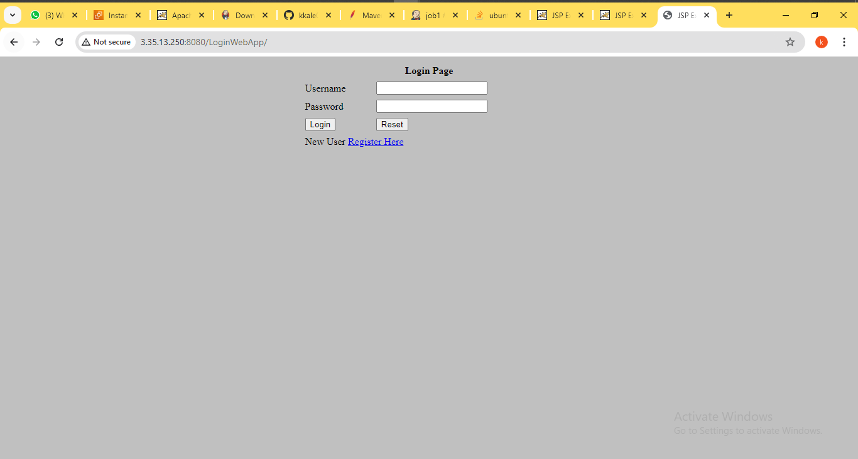

Job2 run successfully on slave2

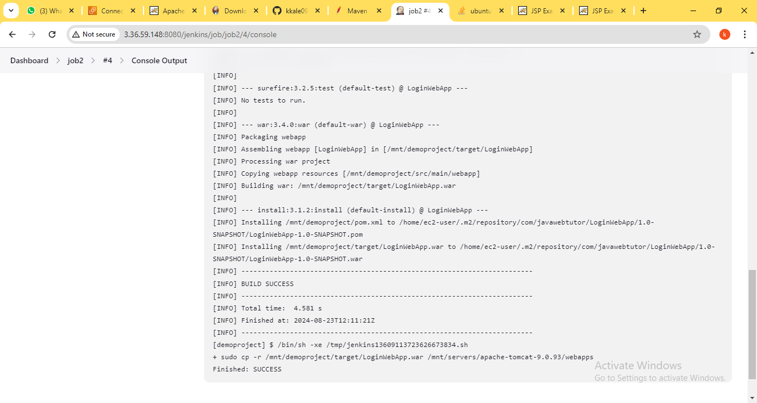

Build and war deploy on slave2

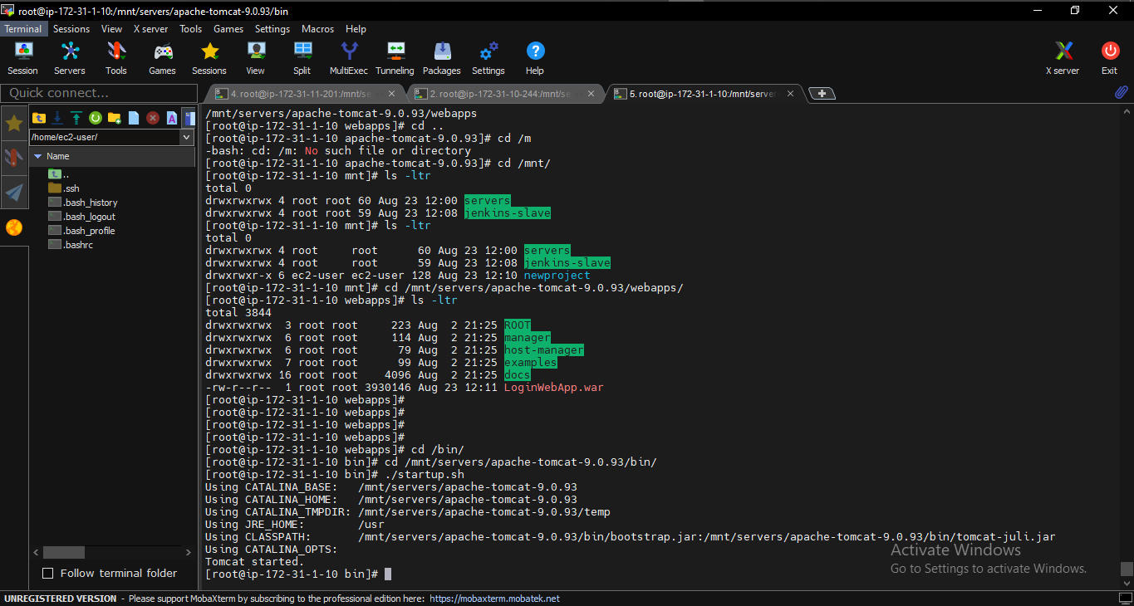

Deploy and confirm on web

